Expression
Infix, Postfix, Prefix
- Infix: An infix notation is a notation in which an expression is written in a usual or normal format. It is a notation in which the operators lie between the operands. The examples of infix notation are A+B, A*B, A/B, etc.
- Prefix: A prefix notation is another form of expression but it does not require other information such as precedence and associativity, whereas an infix notation requires information of precedence and associativity. It is also known as polish notation. In prefix notation, an operator comes before the operands.
- Postfix: In postfix notation, an operator comes after the operands.
Precedence:
Each operator has a precedence level. Operators of higher precedence are used before operators of lower precedence. The only thing that can change that order is the presence of parentheses. The precedence order for arithmetic operators places multiplication and division above addition and subtraction.
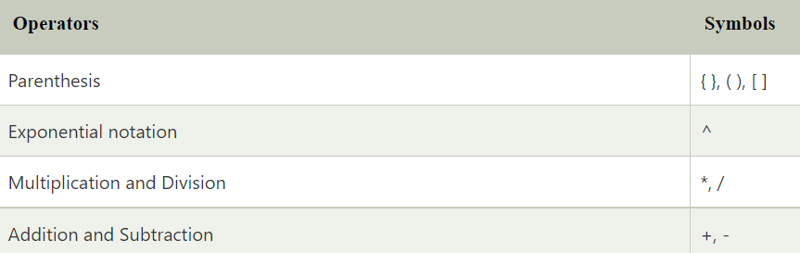
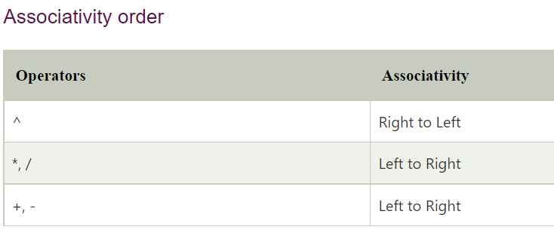
If two operators of equal precedence appear, then a left-to-right ordering or associativity is used.
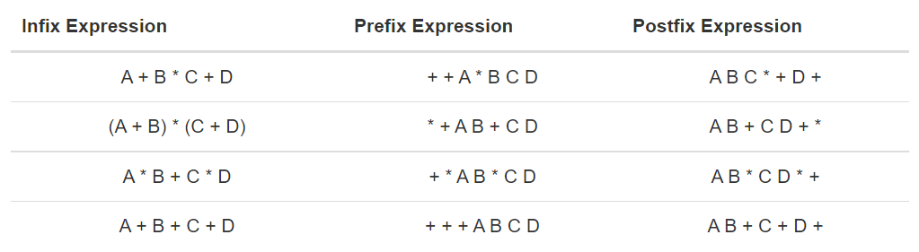
Conversion
Infix to prefix:
K + L - M * N + (O^P) * W/U/V * T + Q
The Reverse expression would be:
Q + T * V/U/W * ) P^O(+ N*M - L + K OR Q + T * V/U/W * (P^O)+ N*M - L + K

Q + T * V/U/W * )P^O(+ N*M - L + K
g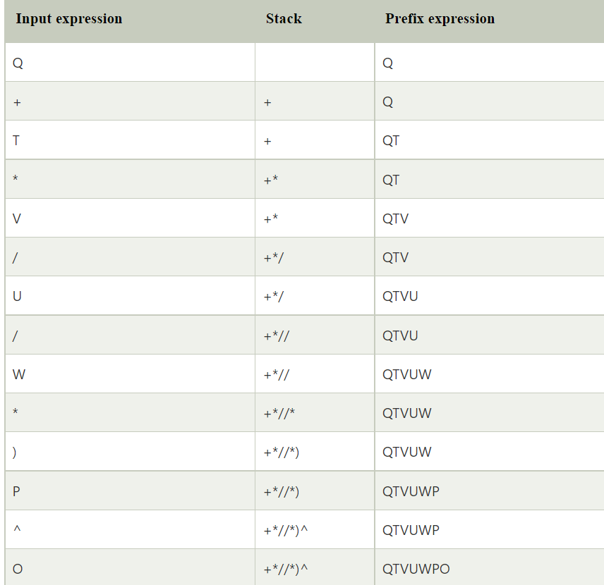
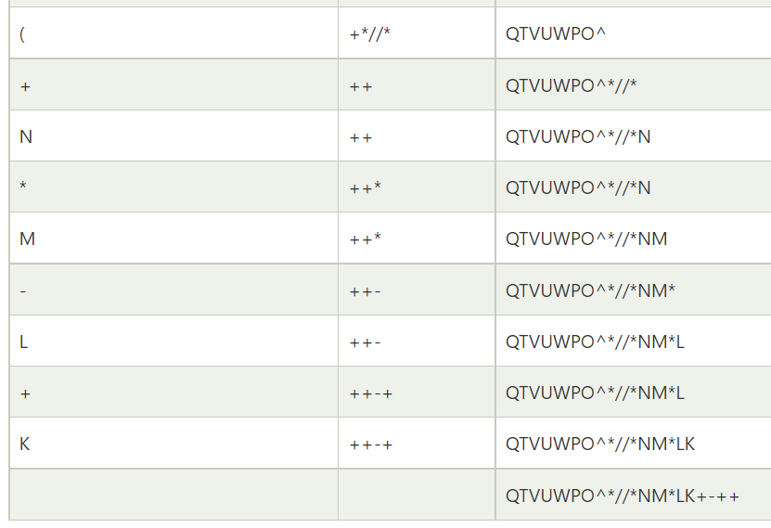
Now Reverse the final expression

Infix to Postfix
K + L - M*N + (O^P) * W/U/V * T + Q
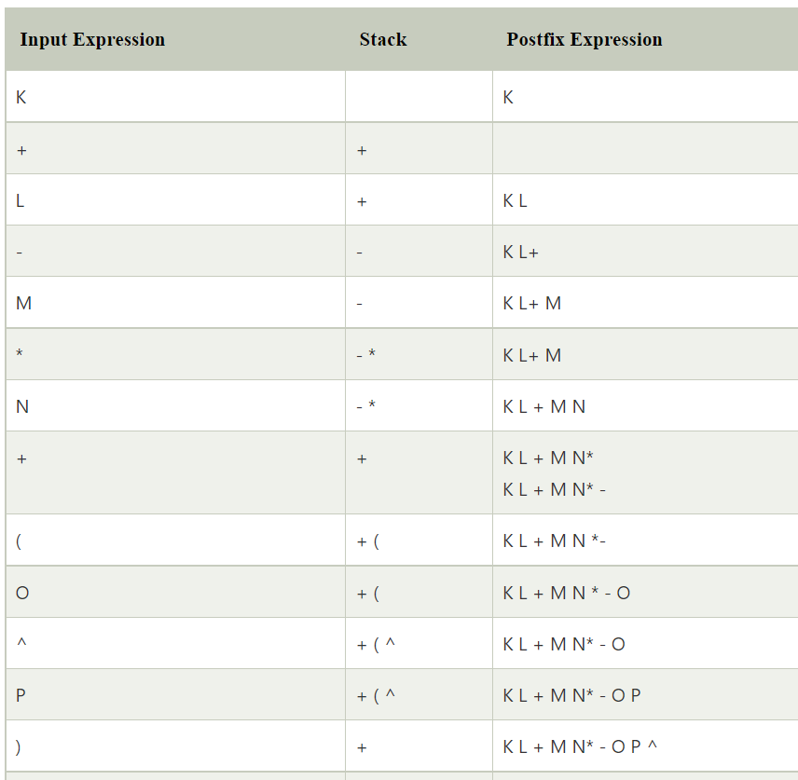
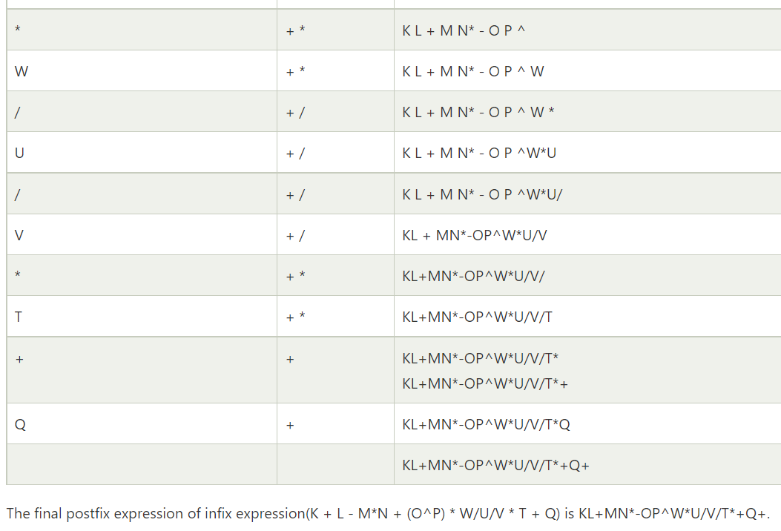
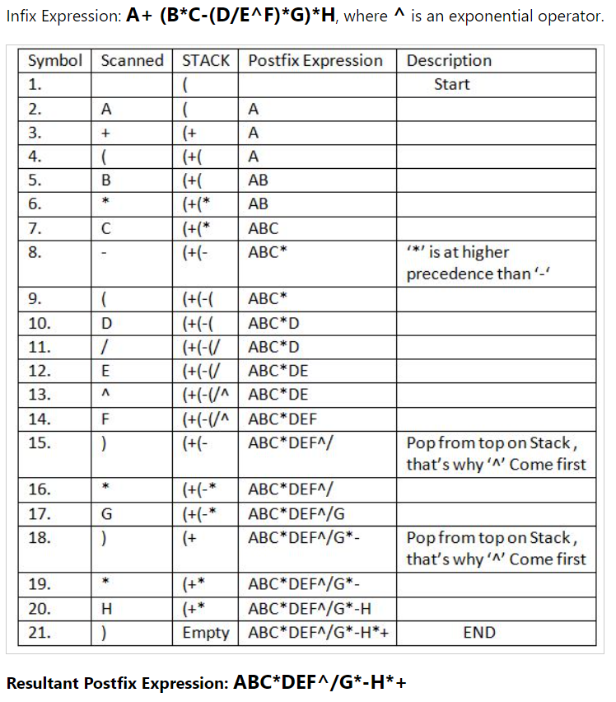

Practice Task:
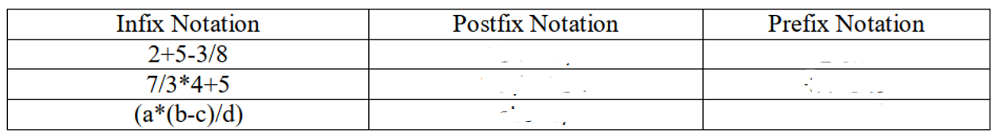

a+b*(c^d-e)^(f+g*h)-i

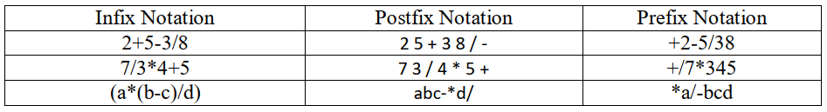
abcd^e-fgh*+^*+i-

